SIMATS ENGINEERING

ASSESSMENT TOOL 3

COURSE NAME: Artificial Intelligence COURSE CODE: CSA17

COURSE OUTCOME COVERED

CO1: Apply AI basics such as intelligent agents and uninformed search methods to solve problems effectively. (BL3)

Assessment Tool Weightage: 40%

QUESTIONS: 5 Duration : 1 Hour
Total Marks:50

Annexure A

Analytical Problem Solving

Code of Conduct:

I N.sri vara Deepak(192572075) (Name / Reg No) certify that this submission is my original work and that I have adhered to the guidelines specified for this assessment.
I understand that any violation of academic integrity rules will result in disciplinary action.

Signature of the student:

DEEPAK.N
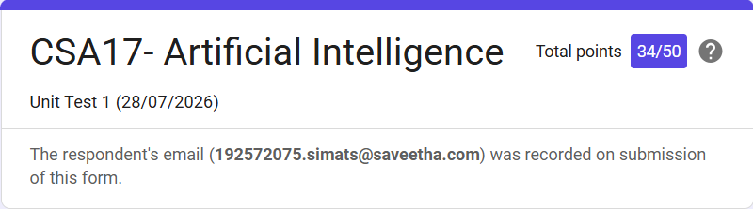V

